ORDINANCE OF THE MAYOR AND BOARD OF ALDERMEN OF THE CITY OF BYRAM, HINDS COUNTY, MISSISSIPPI
AMENDING THE OFFICIAL ZONING ORDINANCE AND MAP OF THE CITY OF BYRAM, MISSISSIPPI TO REZONE REAL PROPERTY LOCATED AT 12900 SPRINGRIDGE ROAD (PARCEL NO. 4851-526),
IN THE CITY OF BYRAM, HINDS COUNTY, MISSISSIPPI, BY CHANGING THE USE DISTRICT CLASSIFICATION FROM (C-4) TO (R-E)

WHEREAS, Trey and Tressa Hammond (the "Petitioners") did make a request to rezone certain property described herein from its present (C-4) Major Thoroughfares Commercial District Classification to (R-E) Residential Estate District Classification (the "Petition"); and,
WHEREAS, at its regular public meeting held on April 10, 2023, the Development Review Committee ("DRC") recommend the matter be directed to the Mayor and Board of Aldermen for approval, and thereafter voted to recommend that the Petition be approved; and,
WHEREAS, the Petitioner did provide evidence to the City of Byram that all notice requirements had been met of both statute and as provided under the Zoning Ordinance of the City of Byram; and,
WHEREAS, the City of Byram did cause notice of the April 13, 2023, public hearing to be published in The Clarion Ledger, a newspaper published in the City of Byram, Hinds County, Mississippi, in the manner and for the time required by law on March 27, 2023; and,
WHEREAS, at the time, date and place specified in the notice, the Mayor and Board of Aldermen of the City of Byram, Mississippi, did conduct a full and complete public hearing on the Petition, and received comments and heard evidence presented by the Petitioner.
WHEREAS, the Mayor and Board of Aldermen are fully familiar with the request and the property and existing land uses within the City of Byram and in the area of the City where the property is located, and in acting on this Ordinance, have duly considered the matters and facts

within their personal knowledge as same affect the land uses required in the Petition; and,

WHEREAS, the matter was presented to the Mayor and Board of Aldermen along with the recommendation of the Development Review Committee ("DRC"), and after discussion thereof,
Alderman G / e, S o .J offered the following Ordinance and moved that it be adopted,
to-wit:

NOW, THEREFORE, be it ordained by the Mayor and Board of Aldermen of the City of Byram, Hinds County, Mississippi as follows, to-wit:
SECTION 1. That the matters and facts stated in the preamble hereof are found, determined and adjudicated to be true and correct.
SECTION 2. That it is hereby found and determined that the conditions precedent to the granting of a Petition to amend the City of Byram Official Zoning Map as required by Section
5.600.16 of the City of Byram's Official Zoning Ordinance of May 23, 2019, exist and have been satisfied in regard to the granting of the Petition, and specifically, the Mayor and Board of Aldermen do hereby find and determine that the character of the neighborhood where the property is located has changed to such an extent as to justify the reclassification of the property, and that there is a public need for the rezoning and the land use requested in the Petition.
SECTION 3. That certain property as described below owned by Trey and Tressa Hammond be re-zoned from C-4 (Major Thoroughfares Commercial District) to R-E (Residential Estate District Classification).
SECTION 4. That the Use District Classification of the following described property be, and same is hereby changed from its, present (C-4) Classification to (R-E) Classification as to the following described property (the "property"), to-wit:

142 FT E/S SPRING RIDGE RD X 426 FT BK ON N/S BEG 150 FT S AND 1009.5 FT W OF NE COR OF SE Y4 NE Y4 SEC 33 T4 Rl W TOWN OF BYRAM

SECTION 5. That the City of Byram's Official Zoning Ordinance of May 23, 2019, and the Official Zoning Map be, and same are hereby amended to effectuate this change in zoning classification.
SECTION 6. This ordinance shall be effective thirty (30) days after its passage and after publication of same as required in § 21-13-11 Mississippi Code of 1972.
ORDAINED, ADOPTED AND APPROVED by the Mayor and Board of Aldermen of the City of Byram, Hinds County, Mississippi at a regular meeting thereof held on the ;3-day of April,
rH

2023.

The motion for adoption was seconded by Alderman #.N ..S o .rJ , and the

foregoing Ordinance having been first reduced to writing, was submitted to the Board of Aldermen for passage or rejection on roll call vote with the following results:

Alderman Johnson (Ward 1) voted: A W:f"
I

Alderman Hosey (Ward 2) voted: AV E
I

Alderman Amos (Ward 3) voted: A 'le
I

Alderman Mack (Ward 4) voted:

Alderman Gibson (Ward 5) voted: A V e
I
Alderman Moore (Ward 6) voted: A Y e
I
Alderman Harris-Allen (At-large) voted: .q y
I

WHEREUPON, the Mayor declared the Motion had carried and that the Ordinance was

adopted.

SO RESOLVED, ADOPTED, AND APPROVED by the Mayor and Board of Aldermen of the City of Byram, Hinds County, Mississippi at its regular meeting held on the ! .3/#day of

_A"--'-A#-"/"e--'1-_t. , 2023.
I

ATTEST:

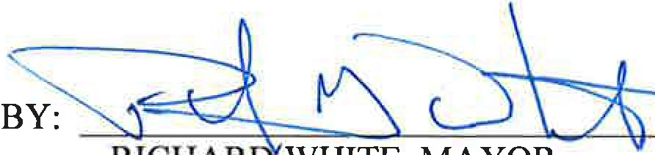CITY OF BYRAM, MISSISSIPPI

BY: d!z;#A- l.
ANGELA RICHBURG, CITY CLERK 'f7
[SEAL]

